Web Api CRUD operation

Existing data using GET
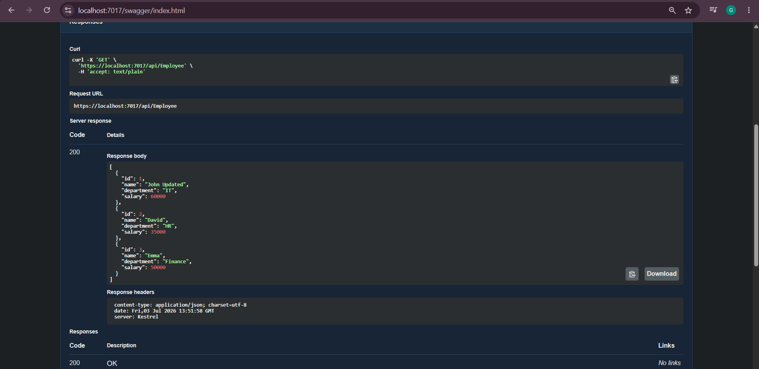

Update the data using PUT:
So I want to update data for ID 1, name and salary is updated to “John” and 70000 respectively. Initially it was “John Updated” and 60000.
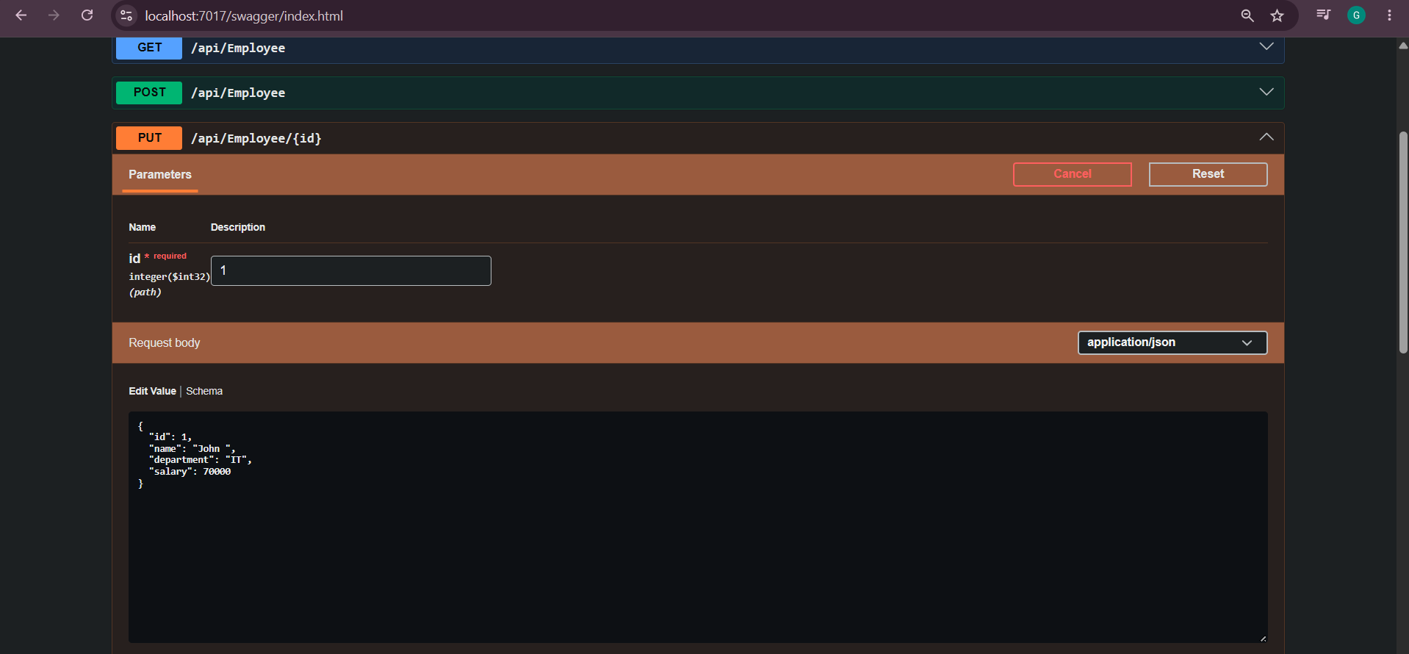

Since the ID is valid and ID is in the hardcoded list , so the data associated with that ID is returned.
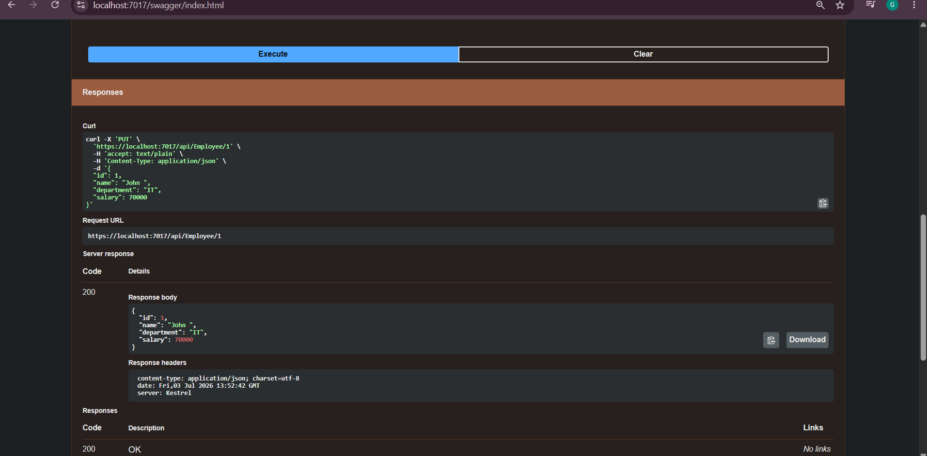

Now checking for ID lesser than 0 or 0 , so it should return Invalid employee id.
Giving -1 as and id(which is invalid).
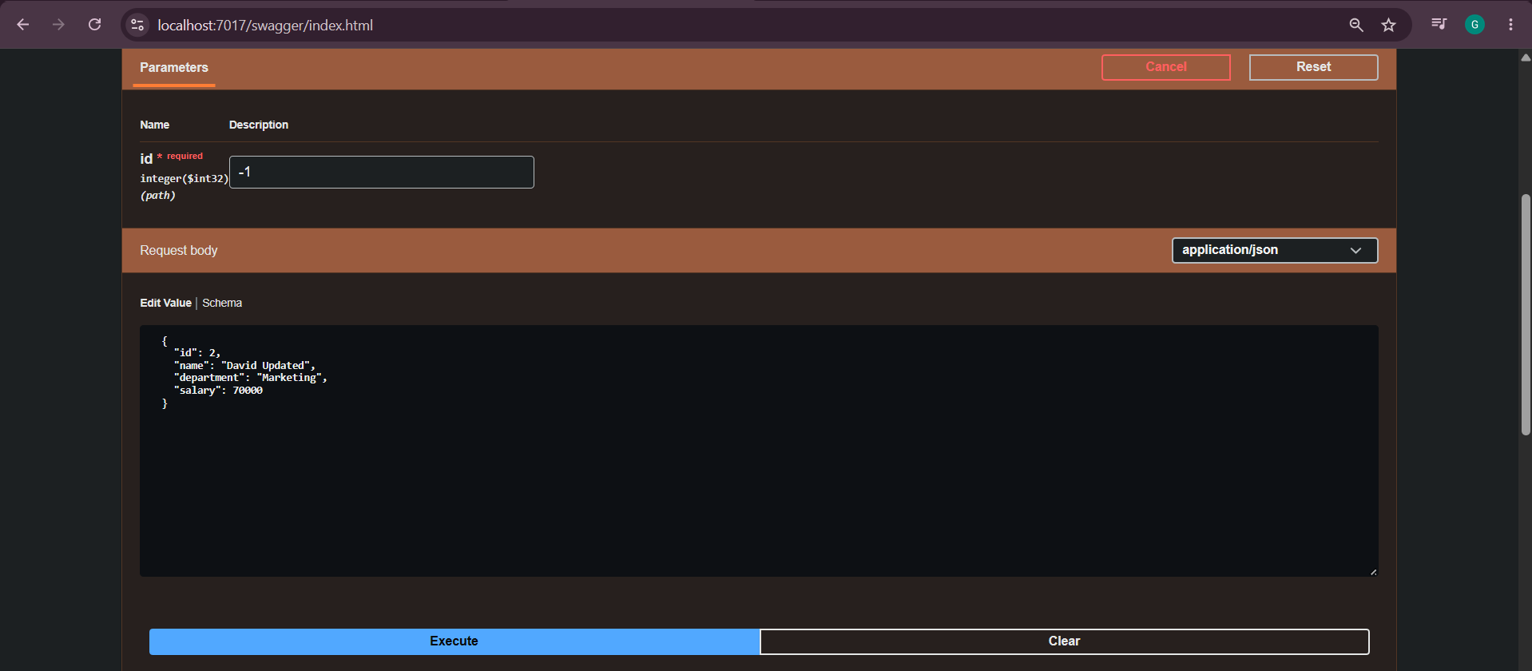

It returned expected result i.e Invalid employee id.
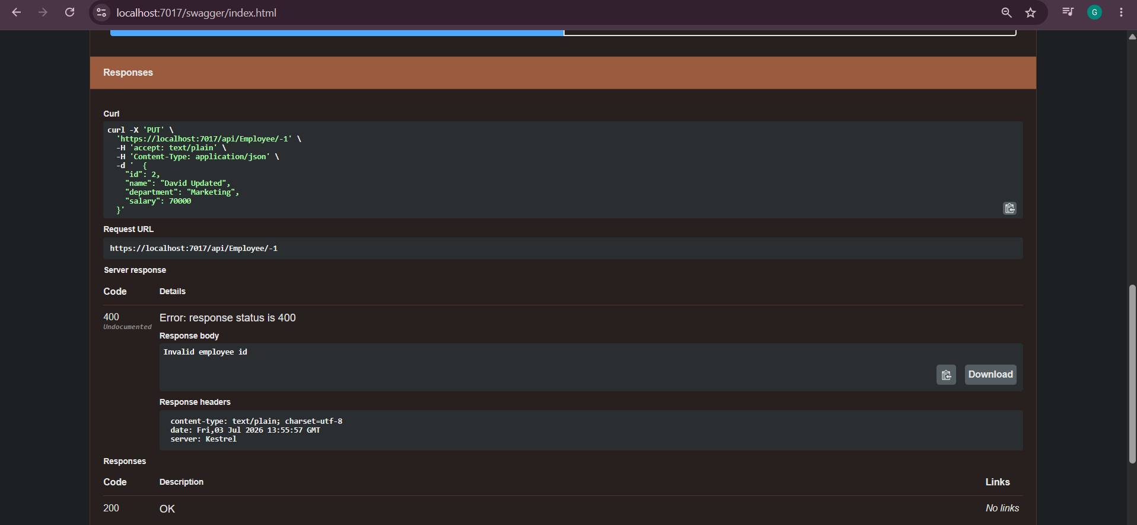

Now checking for even though ID is valid but data is not present in the hardcoded list associated with that ID.
ID 5 is not present.
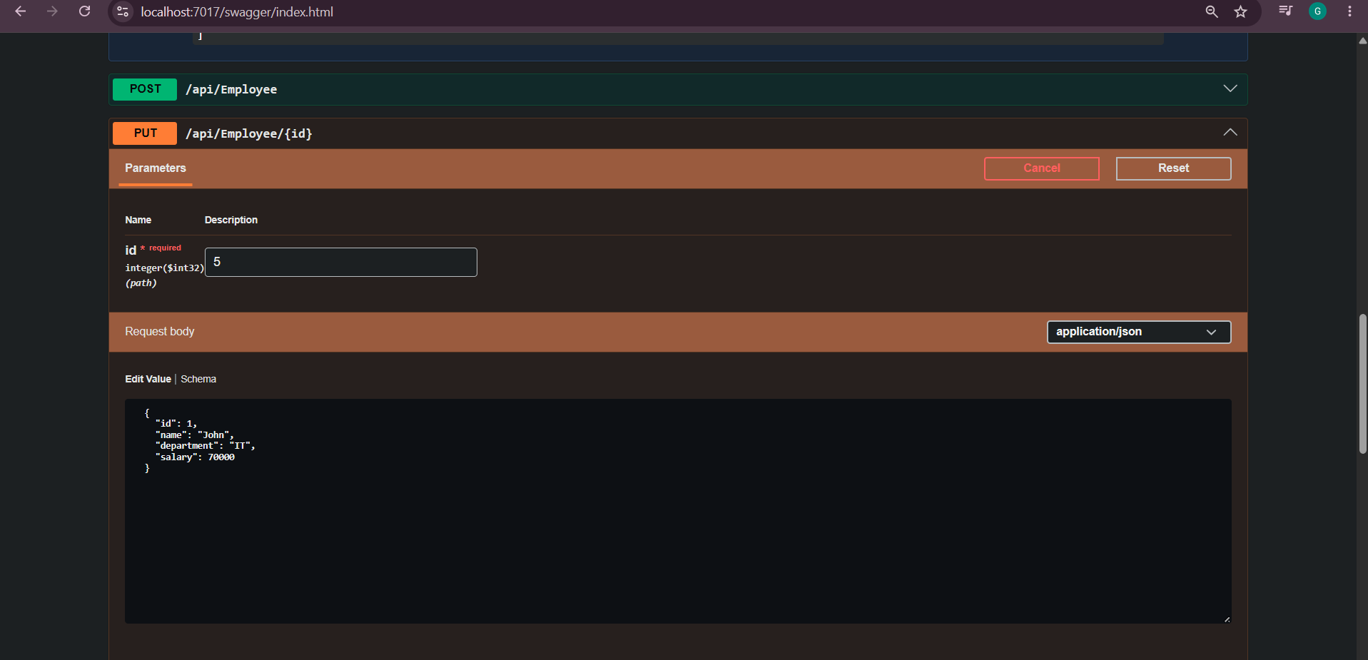

So it again returned same message as Invalid employee id.
